

Assignment 2
Submitted by:
Name | Sapid | Course | Instructor
Aqsa Ahmed | 53106 | Machine Learning | Mam Habiba Khatoon

Assignment: Support Vector Machines (SVM) in Python
Objective:
The goal of this assignment is to apply Support Vector Machines (SVM) for classification on a real-world dataset of your choice. This will help you understand how SVM works, how to preprocess data, and how to evaluate classification models.
Task Instructions:
- Dataset Selection:
  - You must select and download a dataset yourself.
  - You may choose from the suggested datasets below or find your own.
- Steps to Perform:
a. Load and explore the dataset (basic EDA: shape, head, missing values, class distribution).
b. Preprocess the dataset (handle missing values, encode categorical features, normalize/standardize if needed).
c. Split the dataset into training and testing sets (e.g., 70-30 or 80-20).
d. Train an SVM classifier using scikit-learn (sklearn.svm.SVC).
e. Experiment with different kernels (linear, rbf, poly) and compare results.
- Deliverables:
  - A well-documented Python notebook (.ipynb) with code, explanation, and visualizations.
Suggested Datasets :
choose from the following datasets or find your own:
- Wine Quality Dataset (Classification)
  - Task: Predict wine quality (good/bad) based on chemical properties.
  - Source: UCI Machine Learning Repository – Wine Quality
- Breast Cancer Wisconsin Dataset
  - Task: Classify tumors as benign or malignant based on medical features.
  - Source: Available in sklearn.datasets (load_breast_cancer).
- Heart Disease Dataset
  - Task: Predict whether a patient has heart disease based on health metrics.
  - Source: UCI Heart Disease Dataset
- Mushroom Classification Dataset
  - Task: Predict whether a mushroom is edible or poisonous based on its characteristics.
  - Source: UCI Mushroom Dataset

Tasks
- Dataset Selection:

Sample Dataset: Heart Disease Prediction
Dataset: https://drive.google.com/file/d/1nVmh-Ni_Of2PyI-RKPQ7ARzpMnrdks2j/view?usp=sharing
Columns (Features):
- Age – Patient’s age (years)
- Sex – 0 = Female, 1 = Male
- ChestPainType – (0=typical angina, 1=atypical angina, 2=non-anginal pain, 3=asymptomatic)
- RestingBP – Resting blood pressure (mm Hg)
- Cholesterol – Serum cholesterol (mg/dl)
- FastingBS – Fasting blood sugar > 120 mg/dl (0 = No, 1 = Yes)
- RestingECG – (0=normal, 1=ST-T abnormality, 2=LV hypertrophy)
- MaxHR – Maximum heart rate achieved
- ExerciseAngina – Exercise induced angina (0=No, 1=Yes)
- Oldpeak – ST depression induced by exercise (float)
- ST_Slope – (0=upsloping, 1=flat, 2=downsloping)
- HeartDisease – Target (0 = No, 1 = Yes)

- Upload the data set
from google.colab import files
uploaded = files.upload()

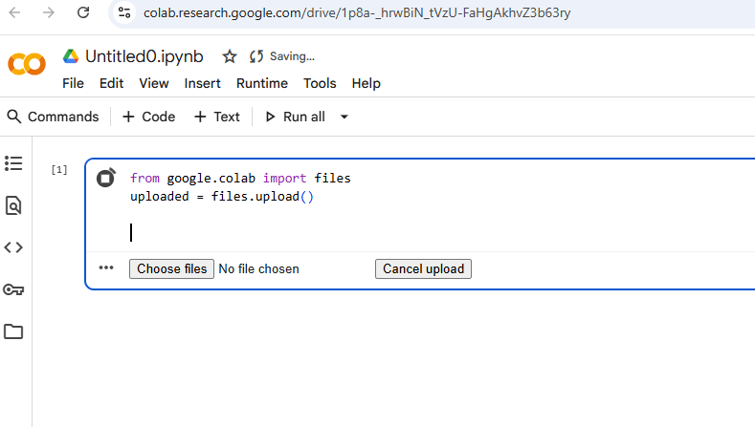

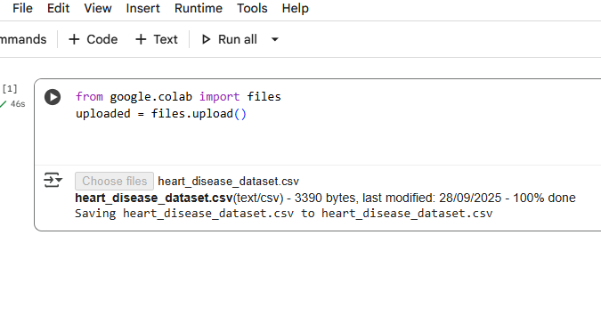

- Load the data set
import pandas as pd
# Load CSV into DataFrame
df = pd.read_csv("heart_disease_dataset.csv")
# Preview first rows
df.head()
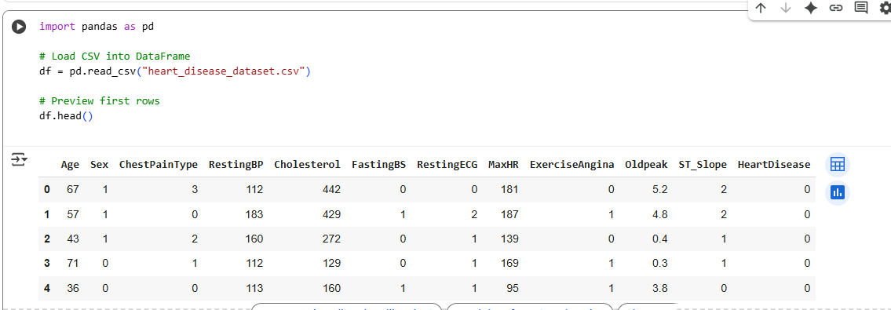

- Explore the dataset (basic EDA: shape, head, missing values, class distribution).
print("Dataset Shape:", df.shape)
# General info
df.info()
# Missing values count
print("\nMissing Values:\n", df.isnull().sum())
import seaborn as sns
import matplotlib.pyplot as plt
# Count target classes
sns.countplot(x="HeartDisease", data=df)
plt.title("Heart Disease Distribution (0 = No, 1 = Yes)")
plt.show()
# Print counts
print(df["HeartDisease"].value_counts())
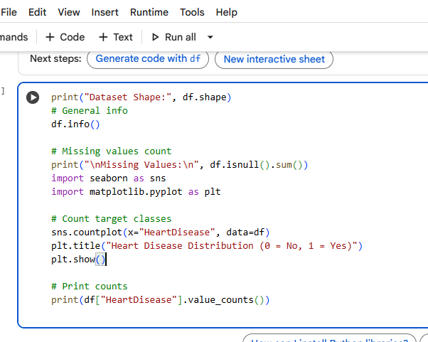
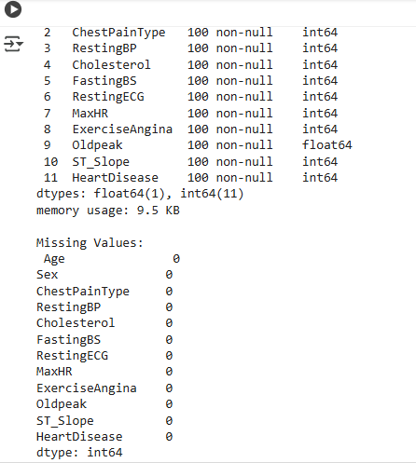
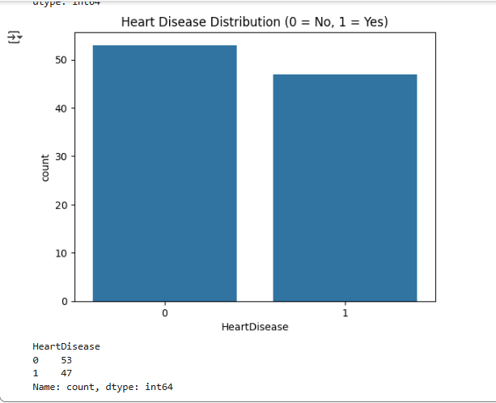
- Preprocess the dataset (handle missing values, encode categorical features, normalize/standardize if needed).
import pandas as pd
from sklearn.preprocessing import StandardScaler
# Load dataset
df = pd.read_csv("heart_disease_dataset.csv")
# Check for missing values
print("Missing Values:\n", df.isnull().sum())
# Features (X) and target (y)
X = df.drop("HeartDisease", axis=1)
y = df["HeartDisease"]
# Scale numeric features
scaler = StandardScaler()
X_scaled = scaler.fit_transform(X)

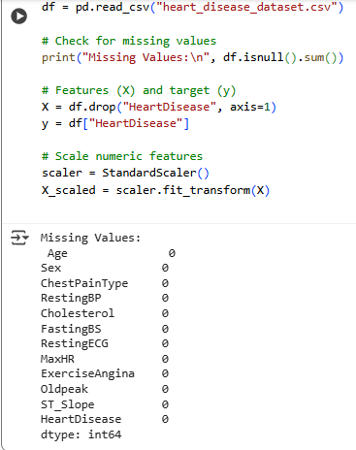

- Split the dataset into training and testing sets (e.g., 70-30 or 80-20).
from sklearn.model_selection import train_test_split
X_train, X_test, y_train, y_test = train_test_split(
X_scaled, y, test_size=0.2, random_state=42, stratify=y
)
print("Training set:", X_train.shape)
print("Testing set:", X_test.shape)
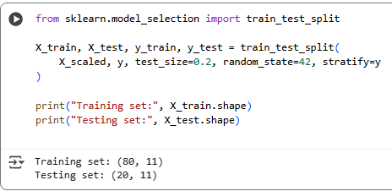
- Train an SVM classifier using scikit-learn (sklearn.svm.SVC).
from sklearn.svm import SVC
from sklearn.metrics import accuracy_score, classification_report, confusion_matrix
# Train SVM with linear kernel
svm_linear = SVC(kernel="linear", random_state=42)
svm_linear.fit(X_train, y_train)

# Predictions
y_pred_linear = svm_linear.predict(X_test)

# Evaluation
print("Linear Kernel Accuracy:", accuracy_score(y_test, y_pred_linear))
print("\nConfusion Matrix:\n", confusion_matrix(y_test, y_pred_linear))
print("\nClassification Report:\n", classification_report(y_test, y_pred_linear))
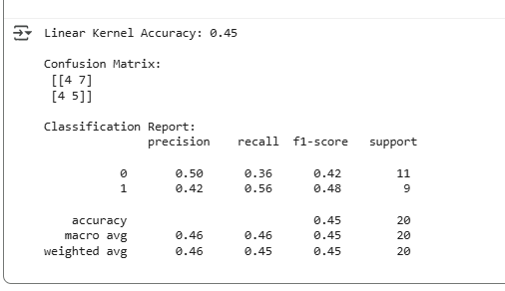
- Experiment with different kernels (linear, rbf, poly) and compare results.

kernels = ["linear", "rbf", "poly"]
results = {}
for k in kernels:
model = SVC(kernel=k, random_state=42)
model.fit(X_train, y_train)
y_pred = model.predict(X_test)
acc = accuracy_score(y_test, y_pred)
results[k] = acc
print(f"Kernel = {k}, Accuracy = {acc:.4f}")
print("\nComparison:", results)
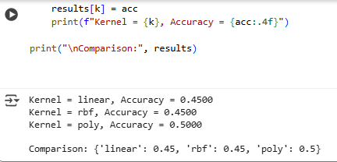ss

🔹 Decision Boundary Visualization

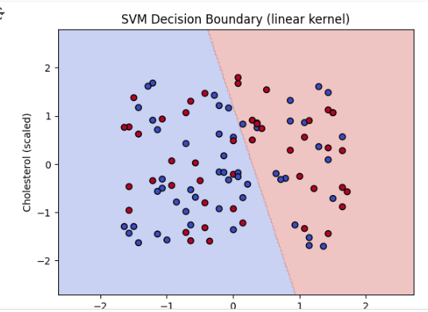
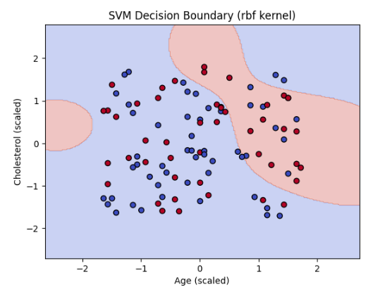
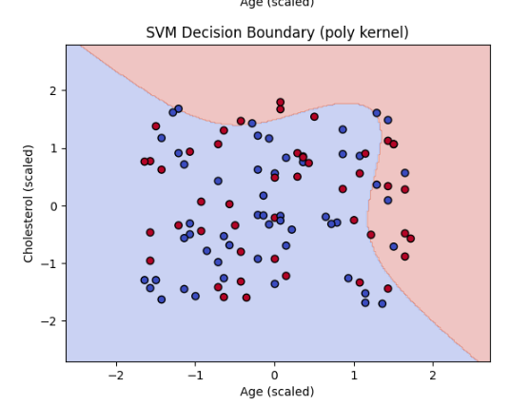
Link: https://colab.research.google.com/drive/1p8a-_hrwBiN_tVzU-FaHgAkhvZ3b63ry?usp=sharing

